How to set a Personal Documentation Filter

1. | If you want to set a document filter to see e.g. only correspondence, you need to be in the record of a patient who has some correspondence
2. | Select the Documentation tab from the left-hand menu
3. | Next to display it will probably say “All”, change this to “Only”  in the boxes that then appear select “Note Type”  and then “Correspondence”  You will notice when you do this, now only correspondence is displayed in the box below  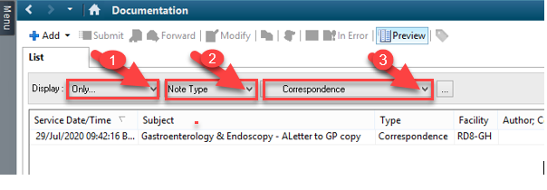
4. | To save this as a personal filter click the button with 3 dots  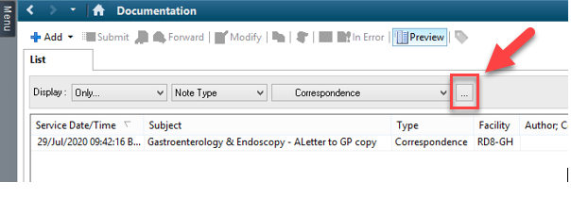
5. | The window below opens, you need to give your filter a name and then click “Apply”, “save” then “close”  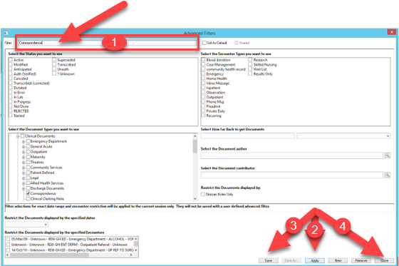
6. | You will see, you now have a new filter under the personal filters section in the Display drop-down menu.  